Name_________________________________________________ Date ____________ Class _________
Ms. Edwards, Kathleen High School
Islam
Foundation date:  _________________________  Founder of the religion:  _________________________  Sacred Cities (2):  _________________________  _________________________  Place of Worship: | Symbol (name and draw it): | 2 Major Religious Texts:  __________________________  __________________________  How they regard Judaism/Christianity:  __________________________  __________________________
What, how, and when do these holidays celebrate?:  Ramadan:  Eid al-Fitr:  Eid al-Adha: | Abraham’s role:  Muhammed’s role: | Additional facts:

On the back, name and explain the 5 pillars of Islam.
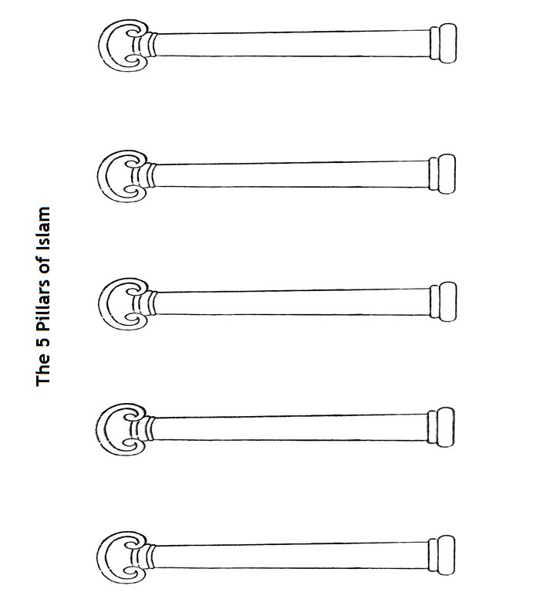
- How are these similar to Jewish and Christian beliefs/practices? How are they different? Be specific!

