Unit 10: Inventions of the Industrial Revolution
Instructions: Use the Industrial Revolutions Inventions PPT to fill out the graphic organizer.
Thread Spinning Mill  Builder: ______________  Year: ______________  Function:  Effect(s):  Rank:  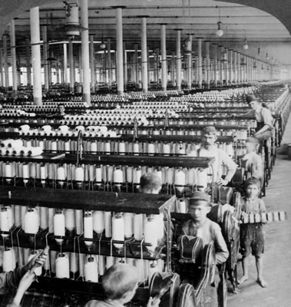 | Cotton Gin  Inventor: ______________  Year: ______________  Function:  Effect(s):  Rank:  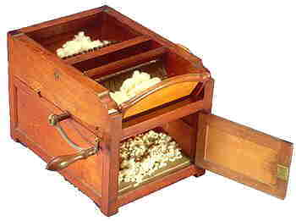 | Steamboat  Builder: ______________  Year: ______________  Function:  Effect(s):  Rank:  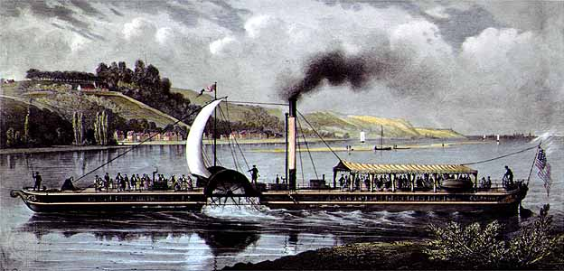 | Mechanical Reaper  Inventor: ______________  Year: ______________  Function:  Effect(s):  Rank:  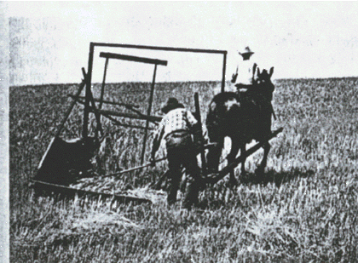

Vulcanized Rubber  Inventor: ______________  Year: ______________  Function:  Effect(s):  Rank:  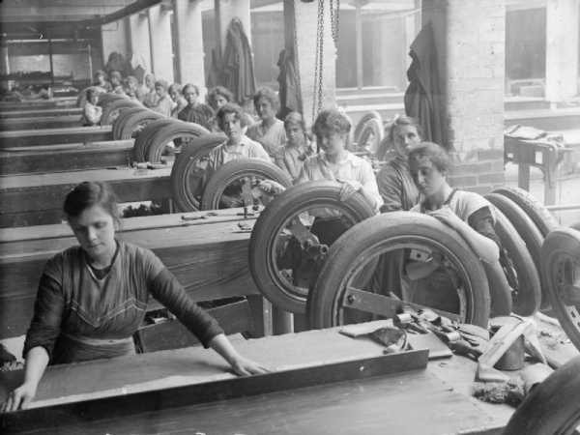 | Steel Plow  Inventor: ____________  Year: ______________  Function:  Effect(s):  Rank:  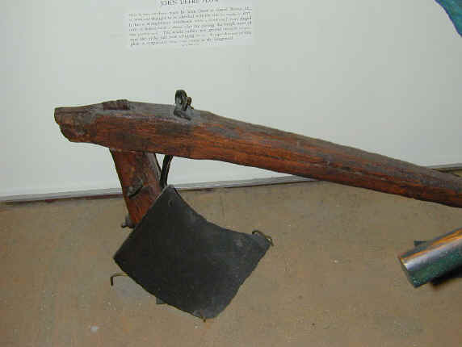 | Telegraph  Inventor: ____________  Year: ______________  Function:  Effect(s):  Rank:  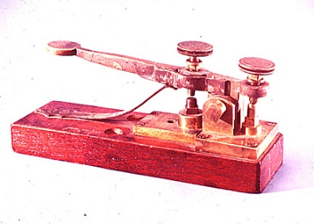 | Sewing Machine  Inventor: ______________  Year: ______________  Function:  Effect(s):  Rank:  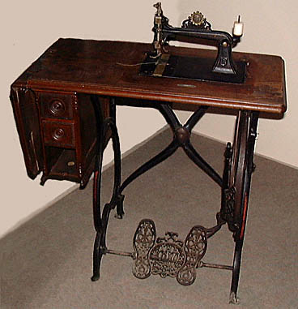

Why did you rank the inventions the way you did? Explain why you picked your “1” and “8” below:

