Unit 11: World War I in 1914

Epic History - WORLD WAR ONE: 1914
- 1914: the Great Powers of Europe are divided into two rival alliances: The Triple Entente: France, Britain and _______________________, united by fear and suspicion of Germany.
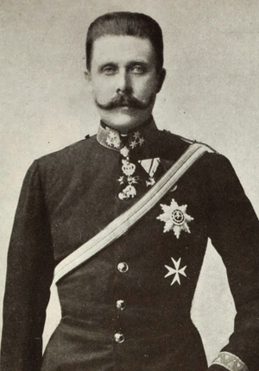
- Europe's new strongest power. And the Triple Alliance: Germany, which fears encirclement by its rivals;_________________________________, clinging onto a fragile empire; and Italy, seeking gains at French expense.
- Who was assassinated in Sarajevo, July 1914 to spark WWI? ______________________________________________________
- The Russian Tsar, Nicholas II, feels honor-bound to ________________ Serbia, a fellow Slav nation, and orders the Russian army to mobilize.
- What was the name of the German plan to avoid a two front war with France and Russia? _____________________________________________________
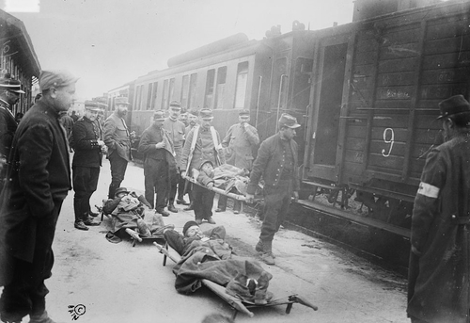
- Who declares war on Germany after Germany invades Belgium? __________________

OPENING MOVES IN EUROPE

7. Where do the Allies finally make their stand? ___________________
- How many miles from Paris? _______

8. The Race to the ________' begins, as both sides try to outflank each other to the north.

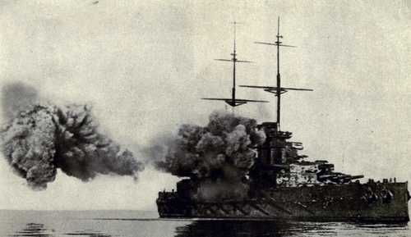
THE WAR AT SEA

9. How many German cruisers were sunk by a British battleship at Heligoland Bight? _______

10. Britain has the most powerful navy in the world: They now impose a naval ____________________ on Germany, preventing contraband goods, including ___________, from reaching it by sea. The aim is to bring Germany's economy to its knees and force it to surrender.

11. What is now herald as deadly new challenge to Britain's command of the seas? German ___ - Boats

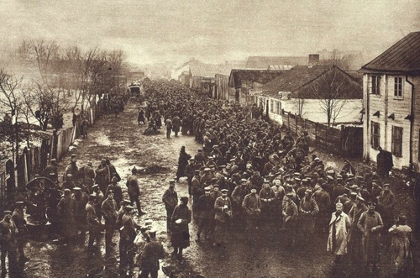
THE EASTERN FRONT

12. In the Battle of Tannenberg, August 1914, how many Russian soldiers were taken prisoner by Germany? ________________________________
13. Austro-Hungary's offensive against Russia also ends in disaster and retreat, with the loss of more than ___________________________________ men.
14. Who ends up joining the Central Powers, declaring war on its old enemy, Russia? _________________________________________

THE WORLD AT WAR
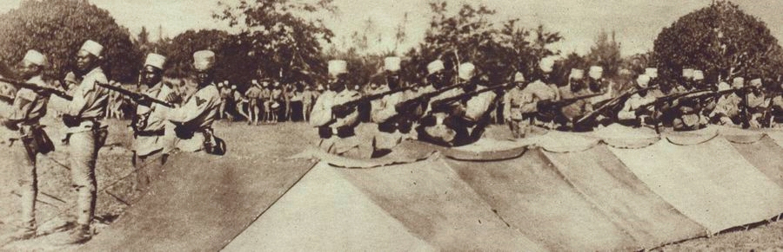
15. African soldiers, known as 'Askaris', fighting in German service in East Africa.
Beyond Europe, the war rages on the world's oceans and in far-flung European _________________________.
16. The German colonies of Samoa and New Guinea surrender to troops from New Zealand and ___________________________________.
17. While in the Middle East, British troops seize control of the Ottoman port of Basra, securing access to the vital Persian _______________ that fuels the British fleet.

WINTER 1914
18. That winter, Austrian troops finally capture Belgrade, but the Serbs then counterattack and drive them back once more. The fighting in Serbia has already cost around ___________ casualties on each side.

19. In the Caucasus, an Ottoman offensive through the mountains in midwinter ends in disaster at Sarikamish. Turkish casualties total 60,000, many ______________________ to death.

20. On the Western Front, the French launch their first major offensive against the German lines: but the First Battle of Champagne leads to small gains at a cost of ___________________ casualties.
21. That first Christmas is marked in some sectors by a short truce, and games of football in _______________________________, the killing zone between the trenches.

