Unit 11: WWI - 1916
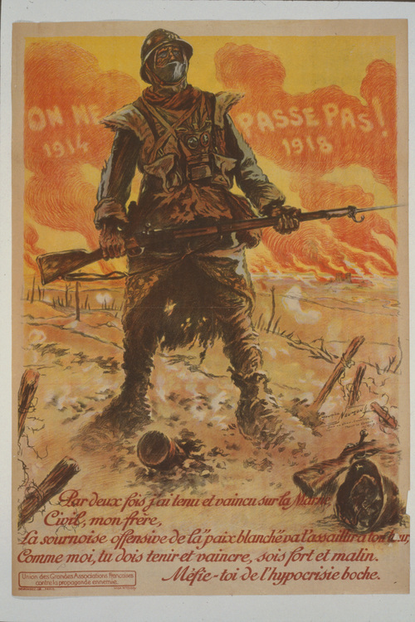
- World War One was supposed to have been a short and glorious war. But by 1916, a new kind of ____________________________ warfare had seen the death toll soar into the millions, with no end in sight.
- The war has raged for a year and a half, as the Allies continue to battle the Central Powers, recently joined by ___________________________
- While on the Balkan Front, the Central Powers have overrun Serbia, whose army is forced to make a bitter retreat through the _____________________ mountains.
- 21 Feb: On the Western Front, the Germans unleash a devastating assault on the French fortress-town of _______________________
- German General Erich von Falkenhayn knows France will defend this symbolic town to the last man. His plan, in his own words, is to 'bleed France white' in its defence. It is the strategy of ____________________.
- What battle becomes one of the most terrifying battles of the war? ______________
- 2 Mar: In Britain, one million men have already volunteered for military service. But the government realises it won't be enough: so in March 1916, Britain becomes the last major power to introduce ________________________________
- 9 Mar:On 9th March, Germany retaliates by declaring war on _________________
- 24 Apr: In Dublin, Irish republicans launch an armed revolt against British rule. It becomes known as the _______ Rising, and is put down after six days of street fighting.
- 31 May: In the North Sea, the German High Seas Fleet clashes with the British Grand Fleet at the Battle of ____________________. In the only major naval battle of the war
- 1 Jul: On the Western Front, Britain and France launch their major summer offensive: the Battle of the ____________________.
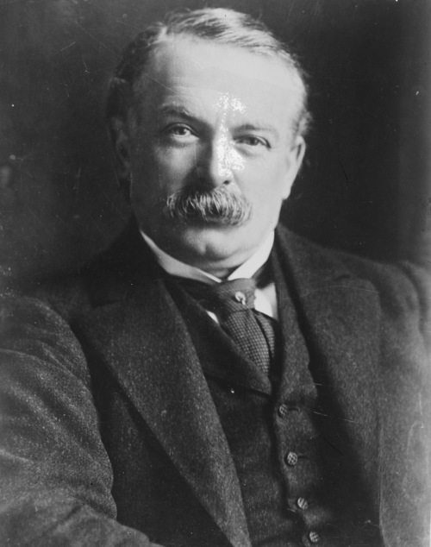
- 29 Aug: Who won the battle of Verdun? ____________________________
- 15 Sep: Meanwhile, the Battle of the Somme continues. What new weapon do the British introduce to the war? ____________.
- 18 Nov: The Battle of the Somme comes to an end amid autumn rain and mud. The Allies have advanced ________ miles at the cost of 600,000 casualties. German losses are about 450,000. The Allies reassure themselves that this is a winning strategy, because at this rate, Germany will run out of ________ first.
- 7 Dec: In Britain, Prime Minister Herbert Asquith is forced from office, and is succeeded by David Lloyd ______________________
- What US president attempts to mediate a peace settlement come to nothing?
________________________________________
- On your own: Why is Germany weary of the United States joining the war?

