Unit 11: WWI - 1917
- 1 February - Germany knows it will lose a long war of _____________________ against the Allies, who have greater resources.
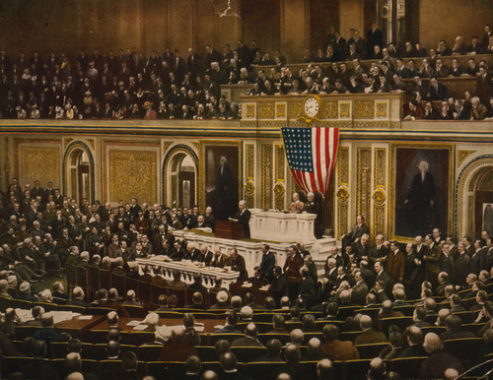
- What weapon does Germany use to cut off Britain's food imports by sea? ______________________
- 19 February - Name of the telegram that Germany sent to Mexico asking them to attack America? ________________________________________________
- 6 April - On April 6th, the United States declares war on ________________________________________
- What do reconnaissance aircraft do?

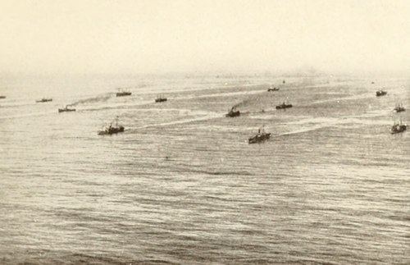
- 7 June - That summer, at Messines Ridge, the British tunnel under the German lines, and detonate ____ enormous mines under the enemy position.
- 2 July - At sea, the Allies begin to group their merchant ships into _________________, which sail under naval escort. The new system leads to a steady fall in losses.
- 4 August - Liberia declares war on Germany, after its capital is shelled by a German ______________________
- 31 October - the British, after two defeats, finally win at the Third Battle of Gaza, clearing the way for an advance into __________________________

- 13 November - What is Prime Ministers Georges Clemenceau nickname? ___________

- 6 December - Finland declares independence from ____________________
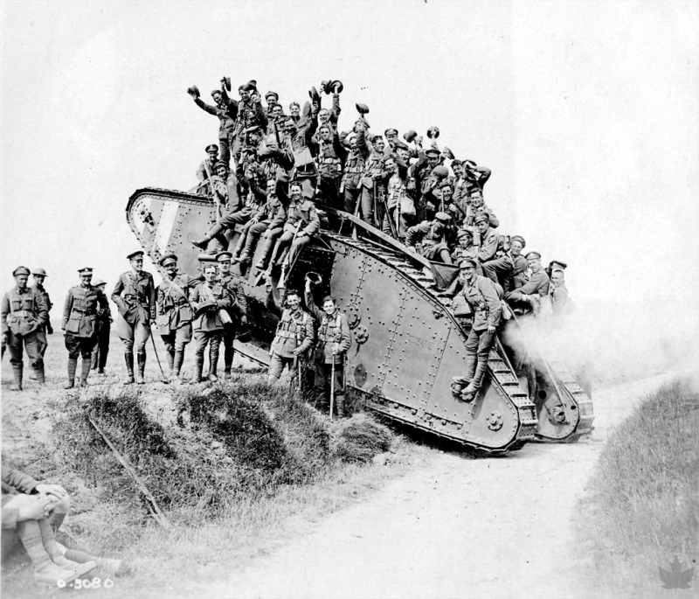
- In 1917 which major allied power is knocked out of the war? ______________________

- In 1917, which major country joins the Allies to fight Germany? ____________________

- In your own words, describe what War of Attrition means?

- Why is America's entrance into WWI significant?

Unit 11: WWI - 1918
- What government has signed an armistice with the Central Powers in 1918?
- Germany faces inevitable defeat, unless it can win a quick victory on the ___________ Front.
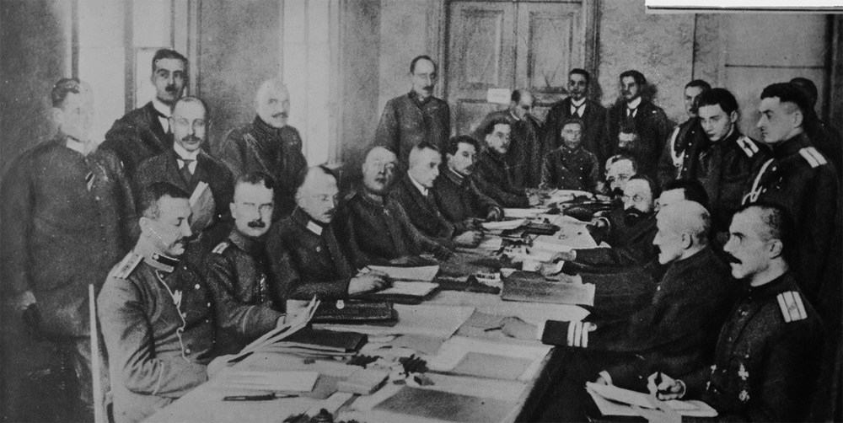
- 8 January - US President Wilson announces his 'Fourteen Points'. They outline his vision for a post-war world, including an end to secret _________________, a reduction in the size of armed forces, ______________________________ for the people of the Austro-Hungarian Empire, and an international organisation to settle _______________ disputes.
- 3 March - What does Russia give up in exchange for peace?

- Why have the Allies won air superiority over the Germans?

- How many victories did the ‘Red Baron’ have and what happened to him near Amiens?

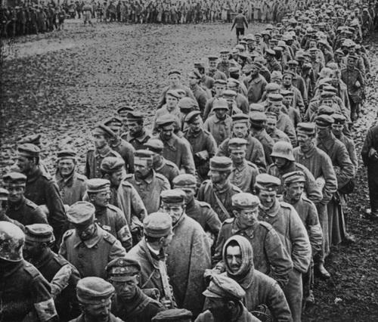
- 15 July - On the Western Front, the Germans' final attack is defeated in the Second Battle of the Marne. How many German Casualties? _______________________
- 8 August - The Allies now go on the attack. German troops are exhausted, hungry and demoralised, and begin to _______________________ in their thousands. Trench warfare is over; the Germans are in full ____________________
- 4 October - Ludendorff informs the Kaiser that the military situation is hopeless, and that Germany must seek an ________________.
- 11 November -What did Germany do on November 11th?

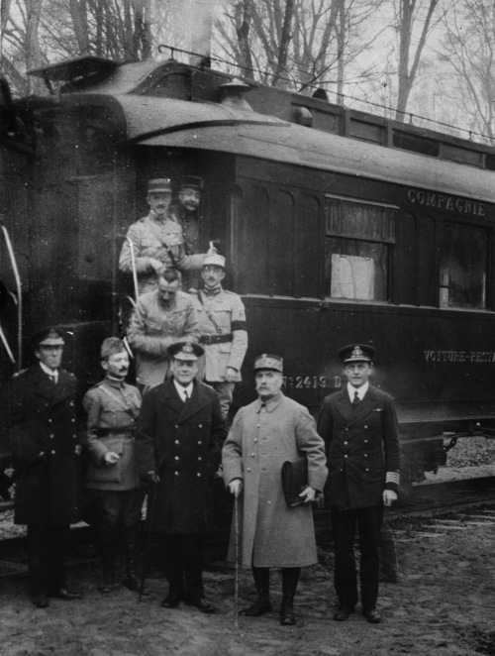
- 18 January 1919 - The Paris Peace Conference opens at the Palace of Versailles, just outside the French capital. Delegates accept a proposal to create a '_____________________________’ to settle future international disputes.
- 4 June - The Versailles Treaty is signed. |t imposes harsh terms on Germany: List 3 things Germany had to do:

- The boundaries of Europe are redrawn: ________________ re-emerges after a hundred years of foreign rule.
- What Empire is dismantled? ________________________________
- How many soldiers were killed in WWI? ___________________________
- How many civilians were killed? ________________________

