Unit 11: Map of Europe 1914
Instructions are on the back!

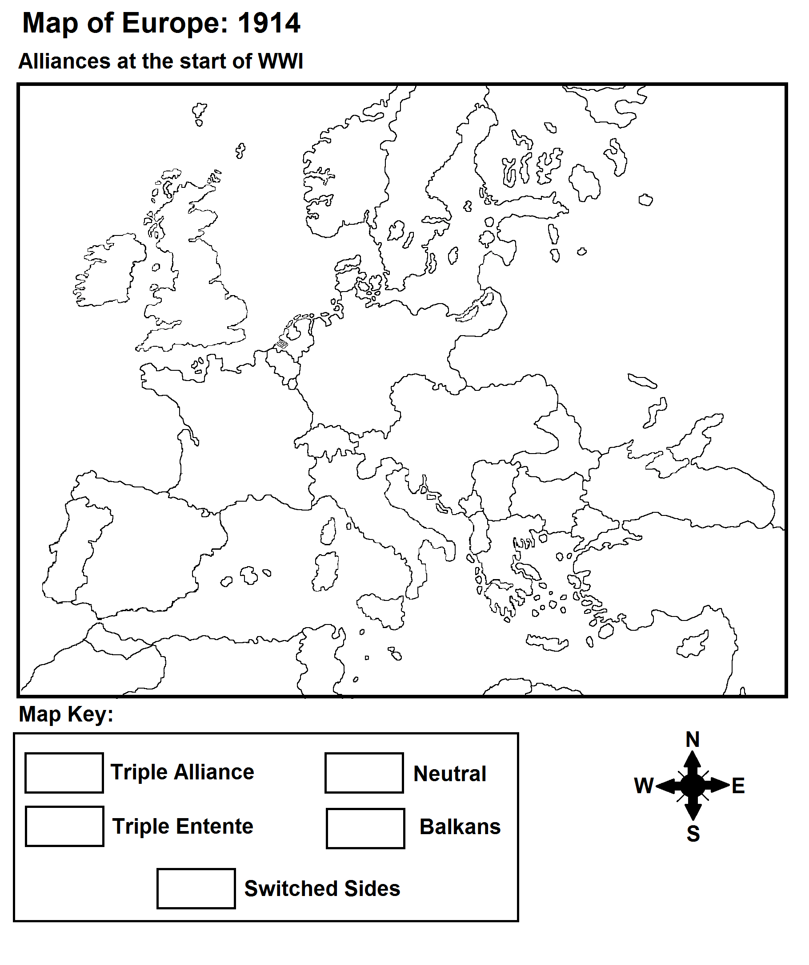

Instructions:
Step 1:
For the blank map of Europe on the other side, find and label the following (cross them off the list as you find them):
Water:
Atlantic Ocean Baltic Sea Black Sea Mediterranean Sea
Countries:
Great Britain Netherlands Belgium Denmark Norway Sweden Portugal Spain France Italy Switzerland Germany Russia Serbia Romania Bulgaria Albania Greece Turkey Montenegro Austria-Hungary
Other:
Africa Arabian Peninsula Sarajevo
Step 2:
Select 3 color pencils. Assign one color each to "Triple Entente", "Triple Alliance", “Balkans”, and "Neutral". Do NOT use blue; leave blue for water.
For "Switched Sides", you will use the same color as "Triple Alliance" but put stripes of another color over it. Color in your map key.
Step 3:
Find out which countries belong in which categories of your map key. Color in these countries accordingly and color all bodies of water blue.
Step 4:
Research the "Schlieffen Plan". Define it below then, on your map, draw it in bold arrows.
_______________________________________________________________________________________________________________________________________________________________________________________________________________________________________________________________
Step 5:
What alliance do you think would win based on the map? Why?
__________________________________________________________________________________________________________________________________________________________________________

