Map of Africa, Trade in West Africa
Instructions: Use pg. 312 in the textbook to color where each of the major empires were on the map below. You will also draw the major trade routes and mark locations for natural resources. Make sure to complete the key on the bottom and draw a compass rose!
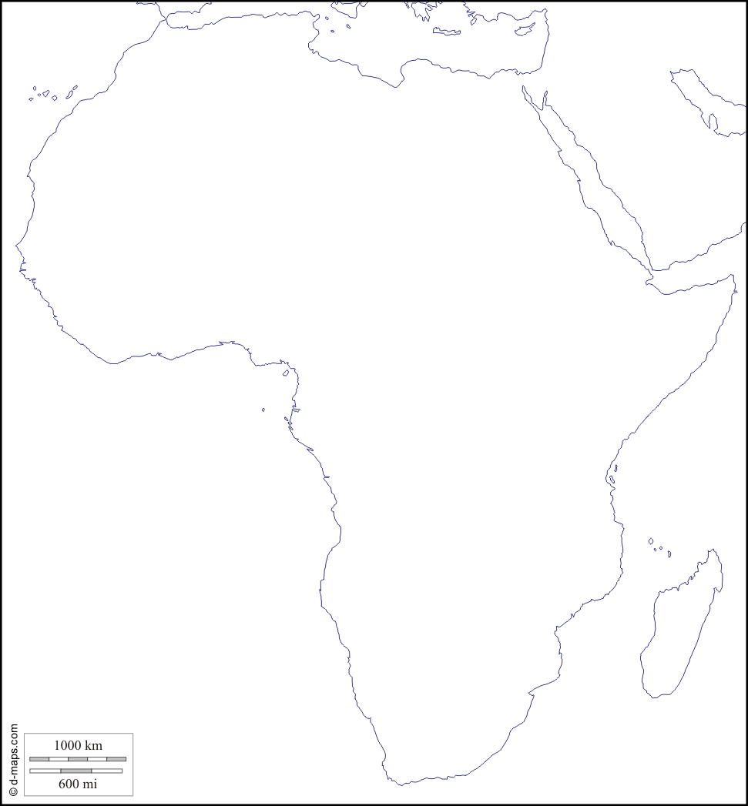
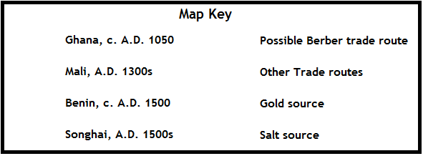
- After finishing your map worksheet using p. 312…
- Using pgs. 311-317:

  - How did the various resources shown on the map make these African kingdoms wealthy?

  - What do the western African cities shown on the map have in common?

  - How did gold help create a strong economy in the kingdom of Ghana?

  - What were the key factors in the kingdom of Songhai’s rise to power?

