Notes from PPT: | Application: Individual Qs
- What years did the civilizations of Ghana, Mali, and Songhai span? | How many total years is this?
- Fill in the blank:  - Sahara Desert:______________ was key trade good – “White Gold”  - __________________: Shore of the Desert: area in between desert and savanna  - Savanna____________________________________: good for growing grains  - Rain forest: wood and edible roots like yams | Why is salt nicknamed “White Gold”?
- All three empires were located near the  __________________and __________________Rivers. | Why was the Niger called the “River of Life”?
- _________________________ was the first great empire.  - Arab _______________________ described Ghana as a fabled “land of gold.”  - Ghana’s succession was _______________________.  - Ghana had a powerful army.  - The use of ___________________ to make tools and ______________________ helped Ghana take control. | Sketch a scenario of a “middleman”
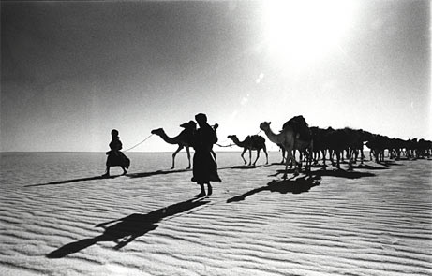
Name_______________________________ Date_________ Class_________
Unit 2: Three 3 Great West African Empires:
Ghana, Mali, and Songhai

note sheet
- Trade  - Ghana becomes wealthy by _____________________ traders. Ghana acted as ______________________ for the ______________________________ from the north and  the ____________________ traders from the south.  - Gold and ____________________ were equal in value.  - Locals practiced silent bartering. | Why do you think traders practiced silent bartering?
- Trade increased between North and West Africa due to the introduction of the camel and the ________________________________ | Sketch a mosque here:
- _______________ brought changes in:  - religious practices  - succession ____________________  - government (more centralized)  - system of ____________ (shari’ah)  - education with Timbuktu becoming a center of learning  - language with _________________ becoming the language of religion, learning, trade and government  - architecture (al-Saheli, built great ___________________ and introduced a new design for houses)  - arts (including calligraphy) | What do you think succession mean?  What other examples of cultural diffusion have we studies?
- Ghana collapsed due to  - a loss of ____________________________________  - and an invasion by the Almoravids. | What other civilization we studied fell due to invasions?
- __________________________ was the 2nd great West Africa Empire  The Golden Age of West Africa occurs under ________________________________ leadership. | Sketch where Mali is located:
- Mansa Musa puts Mali on the world map with his ___________.  Mansa Musa brings scholars back to Mali and make it a __________________________________________. | What is another word for hajj?
- 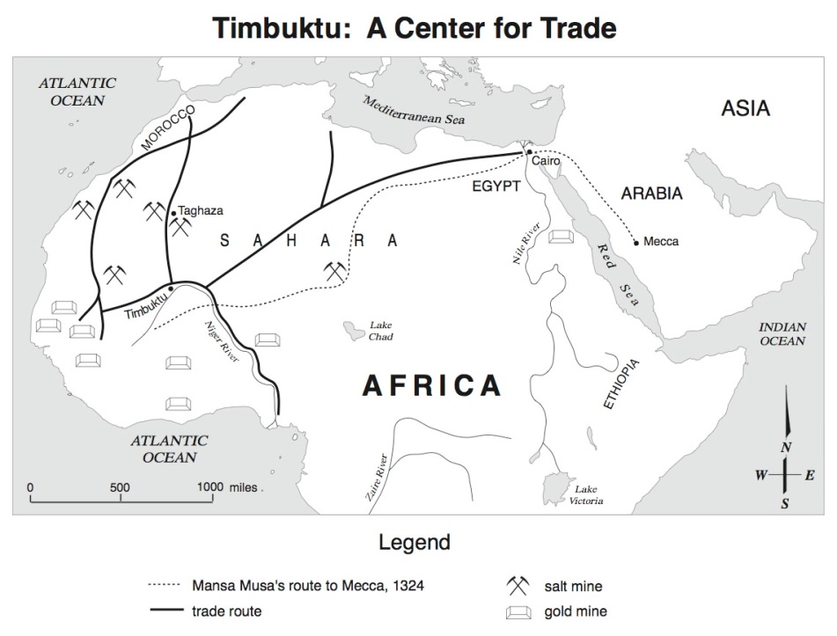  About how many miles was Mansa Musa’s Hajj?  In which part of Africa was salt mined?  Circle the Niger River. | Why was Timbuktu a major point for trade?  What consequences would there be to Mansa Musa’s Hajj?
__________________________-:
Third Great West African Empire
- About 100 years after Mansa Musa’ death, the _____________________________ rise up under Sunni Ali and conquer Mali.
- Under Askia Mohammed Toure, Songhai expands and becomes a strict ___________________________empire.

- Oral Traditions  - ___________________are poet-musicians and historians.  - Folktales were used to pass down history and to teach young people __________________________________________.  - Proverbs are popular sayings meant to express something ____________________________________  - African music has influenced ____, blues, rock and rap music, | What African influence is there in modern America?

