Unit 4: Creating a Coat of Arms
Background Information: Back in Medieval Europe, knights would display a crest, or a symbol, that represented them on the battlefield. The first coat of arms was used to distinguish one knight from another. ... Because of this, knights began to paint symbols on their shields. They eventually began to put the symbol on their banner (flag) and the coat they wore over their armor. This is how it got the name "coat of arms".
Instructions: Go to https://www.fleurdelis.com/meanings.htm (Google search “coat of arms symbols”, 2nd result) create a “coat of arms” that represents YOU using the template below. Use full color! Then, on the back, explain what each color and image means and how it represents you.
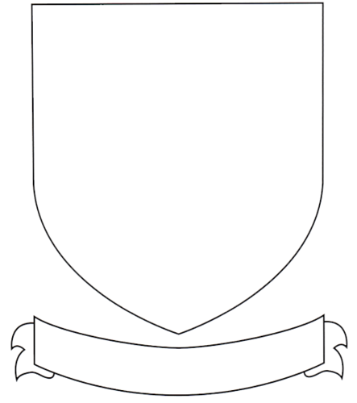
Instructions:
Explain what each color and image you used on your coat of arms means and how it represents you.

_________________________________________________________________________________________________________________________________________________________________________________________________________________________________________________________________________________________________________________________________________________________________________________________________________________________________________
_________________________________________________________________________________________________________________________________________________________________________________________________________________________________________________________________________________________________________________________________________________________________________________________________________________________________________
_________________________________________________________________________________________________________________________________________________________________________________________________________________________________________________________________________________________________________________________________________________________________________________________________________________________________________
_________________________________________________________________________________________________________________________________________________________________________________________________________________________________________________________________________________________________________________________________________________________________________________________________________________________________________

