Unit 4: Daily Life as a Monk/Nun
Instructions: Label each picture with what the monk is doing at that time during his day.
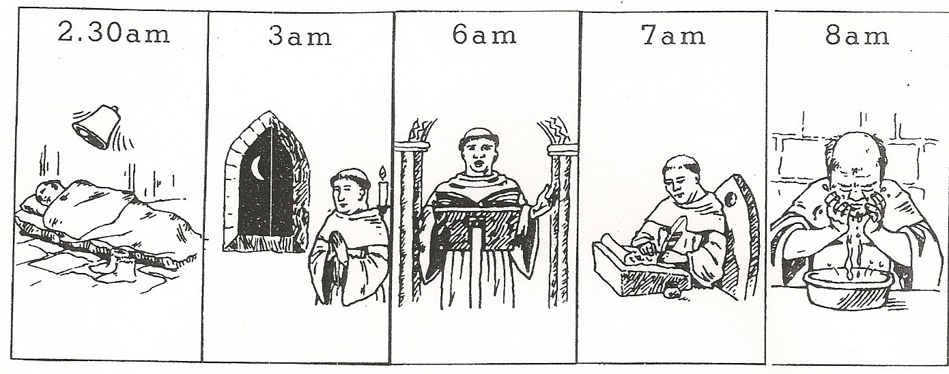

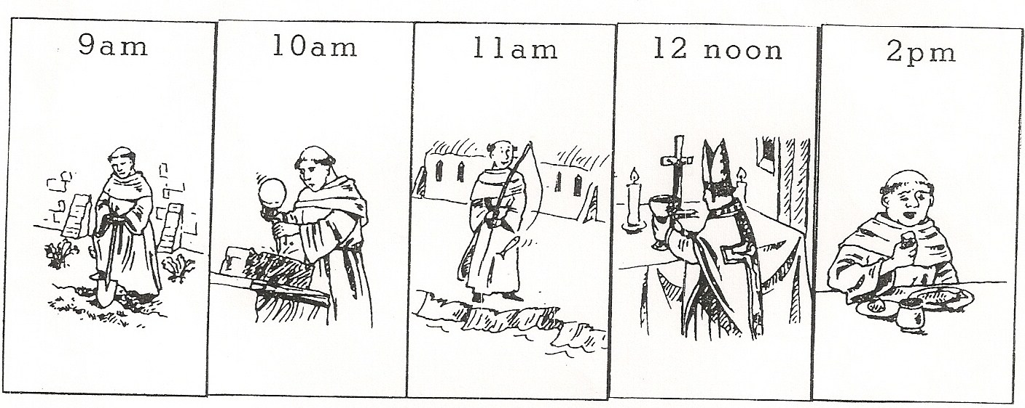

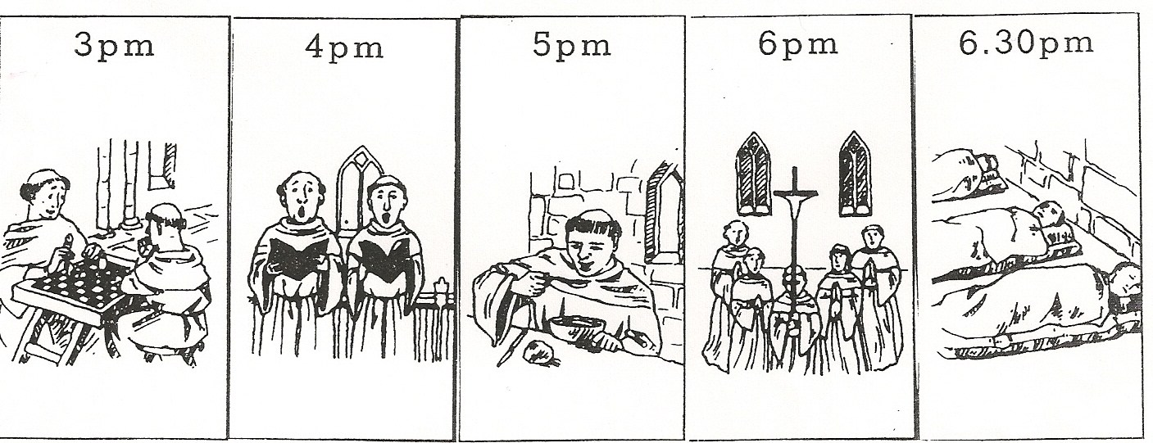

Instructions:
- Imagine that you are a monk or nun and it is your first day in the monastery (or convent, if you are a nun).
- Look at all the things a monk might do in one day (from the front of the paper). Write a diary entry for one day, explaining all the things that you have done – try to include as much detail as you can, such as what food you ate, the jobs you did and how you feel about being in the monastery.
- Use the outline below to help you to structure your work: fill it out as a guide but you must write a full page on a separate sheet of paper in diary/journal format and staple it to this paper. Be creative! Use outside sources to add more detail to the entry.

Dear Diary,
Today was my first day at the monastery/convent. I got up at ……
Once I was awake and dressed, the first thing I did was…

Later in the morning, I…

At 2 o’clock we had lunch, it was…

The afternoon passed quickly as I had plenty of things to do. I began by…

It was soon time for supper, which was…
In the evening I…

Finally, I was able to get some rest…

