Unit 4: Feudalism in Japan
Instructions: As we go through the PPT, take notes! This can be found on the website as well.
_____________________ is an island nation (_____________________) ; it is very _________________________ .
Japan is separated from mainland Asia by the _________________________________________________ .
Japan was influenced by __________________________ and ______________________________ .
China’s influence:

JAPANESE FEUDALISM:
Key People
________________ (all the power)
________________ (little power)
________________ (large landowner)
________________ (warrior, loyal to _______________________)
________________ (mostly farmers)

Samurai: “____________________________________________”
Bushido:

A samurai who lost his honor is expected to _________________________ through the ritual of ____________________________ or __________________________ .

Bushido Code:

1.

2.

3.
4.

5.

6.

Structure of Japanese Feudalism
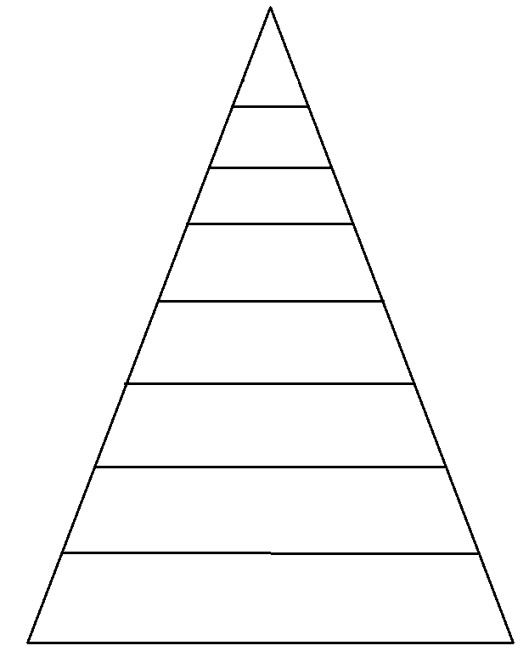
Comparison of Feudalism
Western Europe | Both | Japan

