Unit 4 Quiz 1: Medieval Church
This is a class copy! Use the answer sheet.
Instructions: For questions 1-4, select the CORRECT and BEST word for the definition/description in the question.
- Which of the following is a yearly tax paid to the church, traditionally as 1/10th of newborn animals and harvested crops?
A. Fee B. Tithe C. Catholic
D. Bishopric E. Missionary F. Monk
- This is the religion that dominated Europe in Medieval times:
A. Judaism B. Monk C. Hinduism
D. Islam E. Roman Catholic F. Tithe
- These are the people that spread the word of God in Medieval times; they converted Pagans to Christianity and helped to unify Europe:
A. Nun B. Kings C. Monk
D. Missionaries E. Scribes F. Tithe
- This is the name for a group of Christian communities (parishes) under authority of a bishop:
A. Bishopric B. Monastery C. Parish
D. Convent E. Cathedral F. Church

Instructions: For questions 5-10, read the passage and match the numbered blank with one of the words in the word bank below.
In Medieval times, (5) ____________, the men who gave up everything to devote their lives to God, would live and work in a (6) ______________; they were responsible for many tasks including silent prayer, education of the public, and physical labor to maintain the monastery. Similarly, (7) _____________ were women who devoted their lives to serving God by living and working in a (8) _____________ which was led by an (9) _____________. Both the men and women lived a (10) ______________ life following the rules set by an abbot called Benedict.
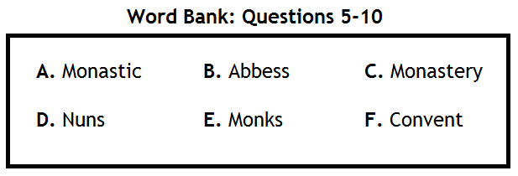
Instructions: For questions 11-15, match the numbered blank with one of the words in the word bank below.
