Unit 9: On the Eve of Revolution
Instructions: Using pages 503 to 516, fill in the chart below. Put causes of the Revolution in the arrows. Include details (bullet point) for each cause!
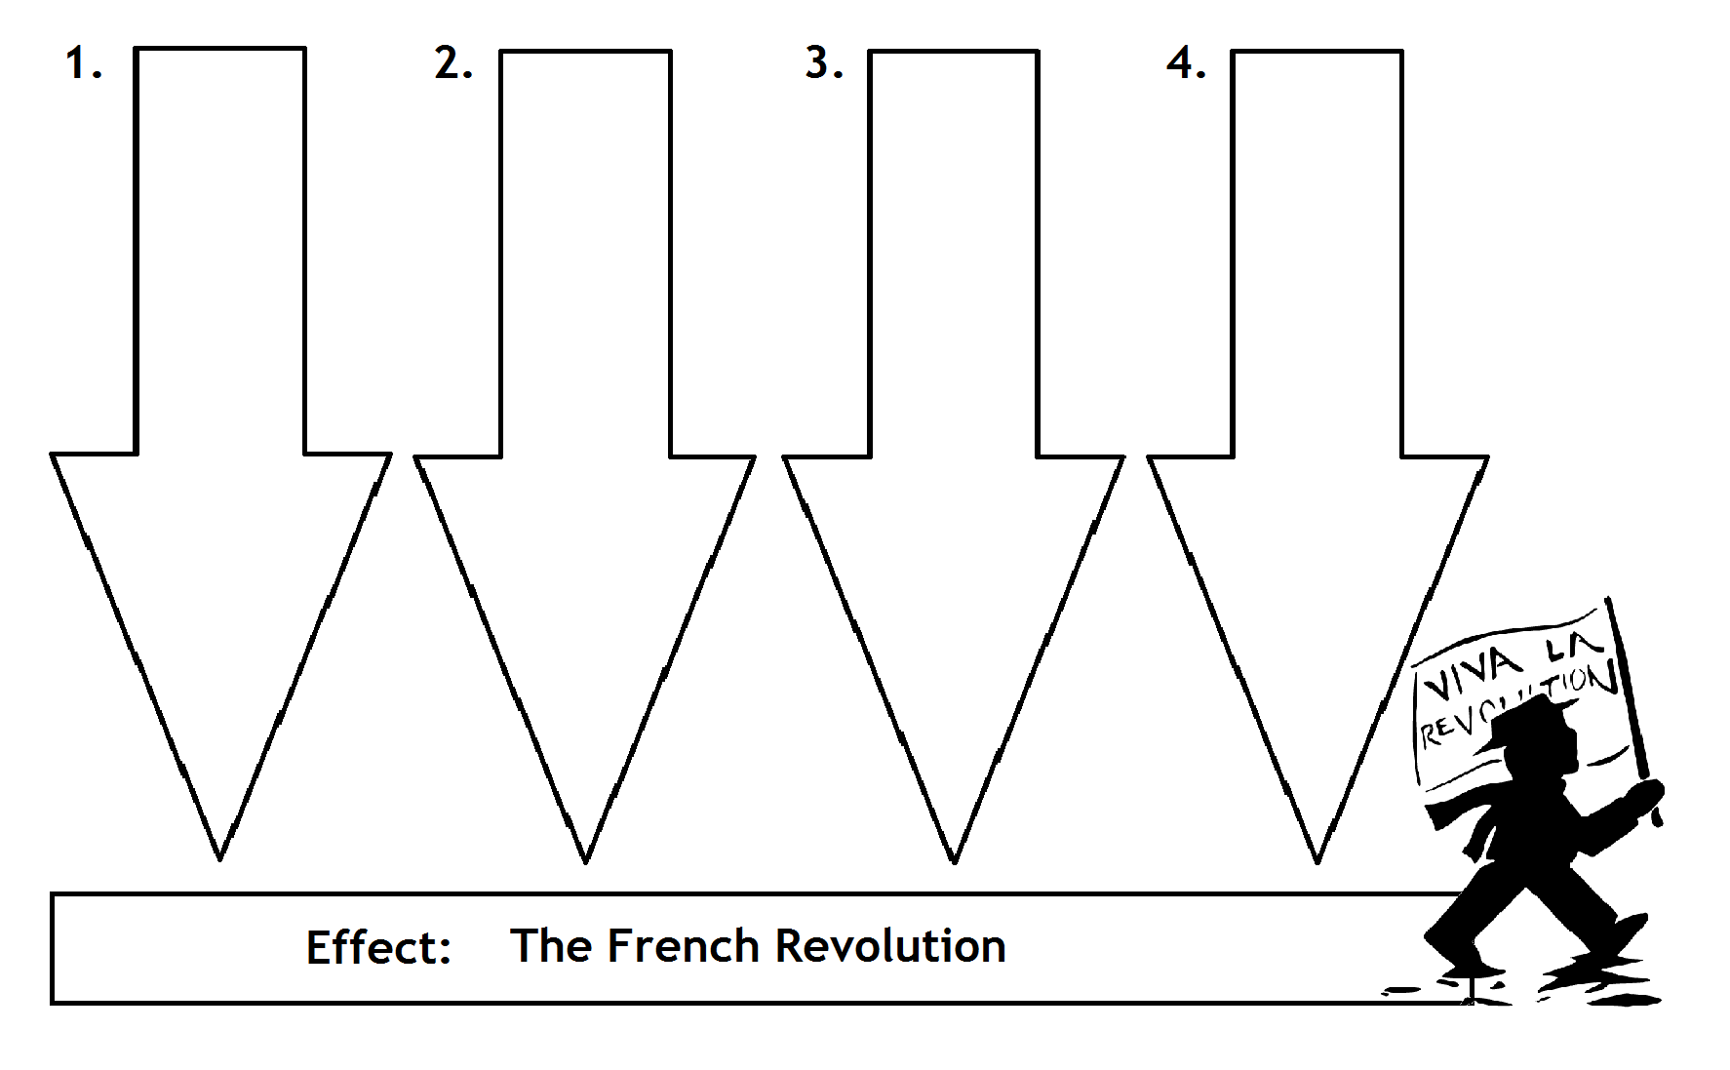
The Old Regime: 3 Estates
Instructions: Using pages 503 to 516, fill in the graphic organizer below. Include who was in each estate, power they had, troubles they faced, what % of the population they were, and their role in the Revolution. Be sure to name the Monarch at the top, too!
