Unit 9: Radical Revolution & Reaction
Instructions: Using pgs. 512-516, complete the timeline below. Add more events and details in the correct place as you see them in the text. I have provided a few events for examples to get you started.
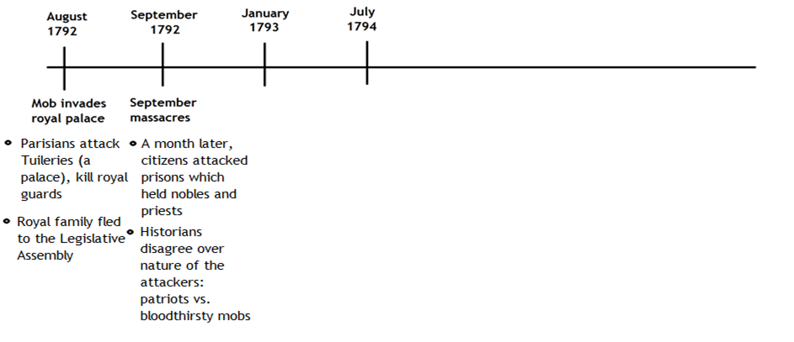

- As you read pages 512 to 516, define or describe the terms below:
Vocabulary Word -> | Domestic | Percent | Electors | Coup d’etat
Definition
Sentence
Picture

- Why did the French Revolution become more radical?

- What do you think the quote below means? Do you agree or disagree with it? Why?
“Terror is nothing but prompt, severe, inflexible justice.”
-Maximilien Robespierre

